

**Huron Heat Female Hockey Association**

PO Box 1651

Clinton, ON

N0M 1L0

May 20,, 2025

To whom it may concern:

The Huron Heat Female Hockey Association ("HHFHA") provides an opportunity for minor aged females in the Huron County area to play hockey. The HHFHA is a nonprofit association that is governed by the Ontario Women's Hockey Association ("OWHA"). The OWHA requires as part of its screening policy, that each person who volunteers to be a member of the HHFHA bench staff has to complete a Criminal Record check that includes the Vulnerable Sector check. Bench staff with the Huron Heat work with the girls on the ice, on the bench and in the dressing rooms.

Please accept this letter on behalf of **YOUR NAME HERE** for your office to perform the police vulnerable sector check. **YOUR NAME HERE** was chosen to be the **BENCH STAFF POSITION HERE**  of our girls hockey team. This role will include off-ice interaction with approximately 18 players, other coaches, officials and parents. This will allow the volunteers for the Huron Heat Female Hockey Association to comply with the screening policy of the OWHA.

If you have any questions, please contact Shane Taylor at shanetaylor@tcc.on.ca

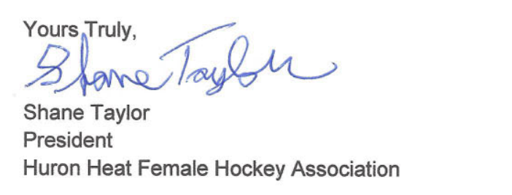

**Fair Play - Fun - Good Citizenship - Integrity - Honesty - Equity**